

***INSTITUTE OF INFORMATION TECHNOLOGY***

***JAHANGIRNAGAR UNIVERSITY***

**Number of Assignment :** 01

**Submission Date :** 18/08/2020

**Course Tittle :** Numerical Analysis

**Course Code :** ICT - 2105

**Submitted To Submitted By**

[Dr M Shamim Kaiser](https://juniv.edu/teachers/rhemel) MD. Shakil Hossain

Professor Roll – 2023

IIT – JU 2nd year 1st Semester

IIT - JU

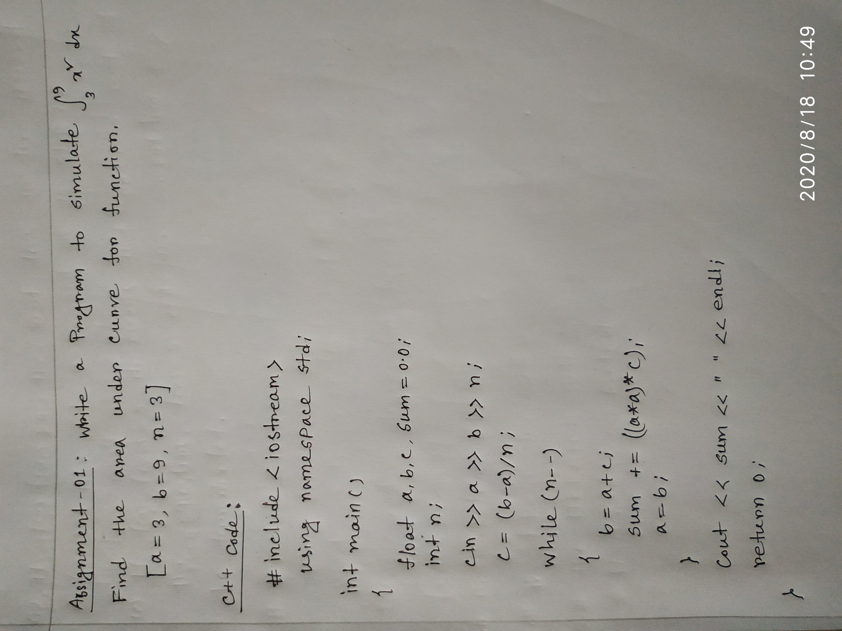**Hand Writing Code**

**Code Blocks Code**

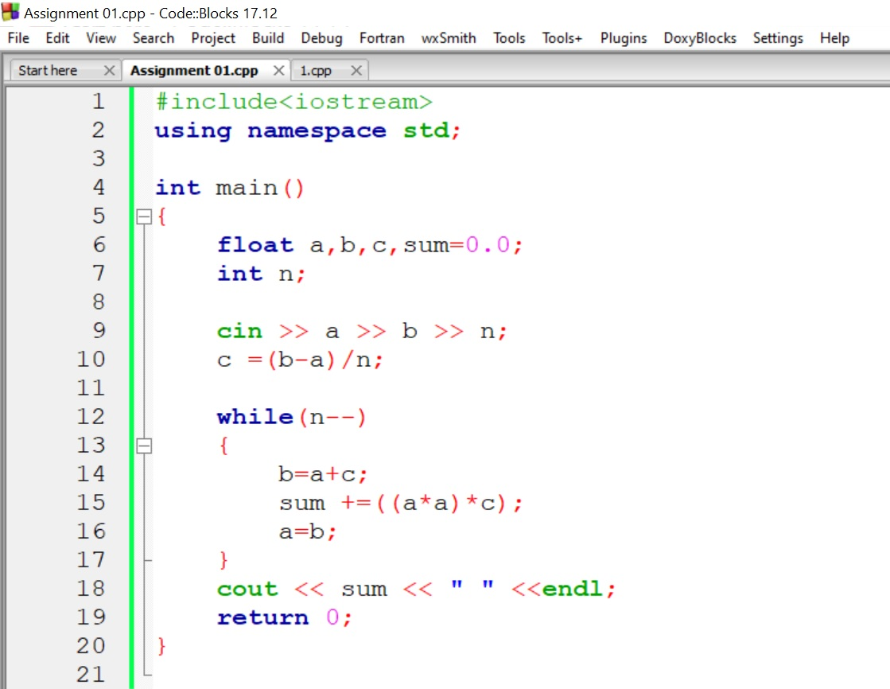

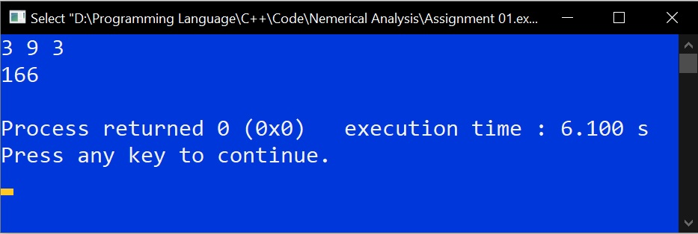**Output**